#include <iostream>

#include <fstream>

#include <map>

#include <string>

using namespace std;

//Use typedef to define StrIntMap as map<string,int>

//YOUR CODE

typedef map<string, int> StrIntMap;

//Function countWord to count the number of word use in as filestream and words as a map container

//YOUR CODE

void countWords(istream& in, StrIntMap& words) {

string s;

while (in >> s) {

++words[s];

}

}

int main()

{

//Define an ifstream object called in to associate the file data.txt

//YOUR COE

ifstream in;

in.open("data.txt", ios::binary);

if (!in)

exit(EXIT_FAILURE);

//Declare w as a map container - key as string , value as integer. Use type StrIntMap

//YOUR CODE

StrIntMap w;

//Call function countWords

//YOUR CODE

countWords(in, w);

//Use a for loop and iterator today display the keys and values

//YOUR CODE

for (StrIntMap::iterator p = w.begin(); p != w.end(); ++p) {

cout << (*p).first << " : "

<< (*p).second << " times.\n";

}

}

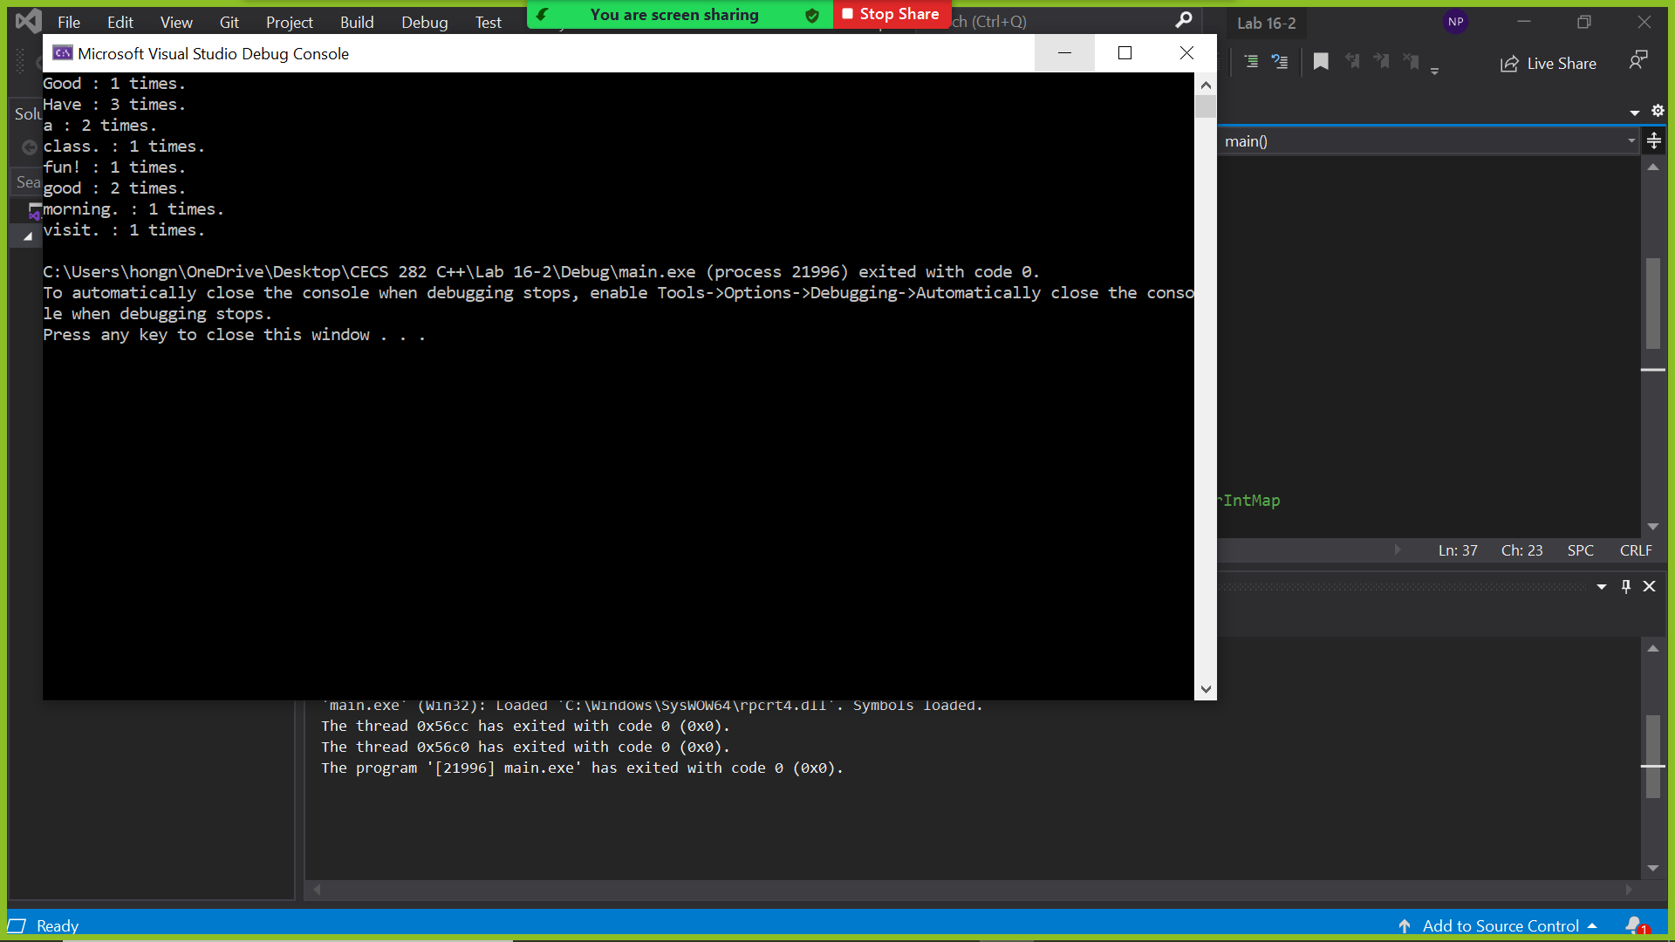

Demonstrated at 11:13 am on 12/7/2021